**EDL Migration Form**

1. Summary

* + 1. **High Level Information [To be filled by the Customer]**

|  |  |
| --- | --- |
| Application Name/Appcode | PPA |
| ISM-IRIS Ticket No. (REQ#/CR#/INC#) |  |
| Requested By | Shirish |
| Requestor J&J WWID |  |
| Requestor Contact Phone |  |
| Requestor Contact Email | [skulka16@its.jnj.com](mailto:skulka16@its.jnj.com) |
| Package reviewed by | Hiresh Roy |
| Jira reference | PD-410 |
| Short Description |  |
| Source Environment (Dev/QA/Prod) | QA |
| Source Objects (Folder/Scripts/Database/Table/View  /UDF/HBase/SOLR etc.) | HQL Scripts, workflows |
| Target Environment (Dev/QA/Prod) ) | PRODUCTION |
| Target Objects  (Folder/Scripts/Database/Table/View  /UDF/HBase/SOLR etc.) | HQL Scripts, workflows, |
| Migration Date | 11-16-2018 |
| Purpose | Migration of HQL Scripts and related workflow changes for PPA from QA to PROD after PROD cluster migration |

1. Functionalities deployed as part of the package

|  |  |  |
| --- | --- | --- |
| JIRA# | Description | Type (Defect or Story) |
| ABFY-12514 | EDL PROD Cluster Migration | Task |

1. Prerequisites & Assumptions
2. Ensure Kerberos authentication is done before executing the scripts
3. Ensure permission are set to a+x for all sh scripts before executing
4. Login using service account
5. Evidence of successful execution in lower environment

* **Package execution evidence from lower environment**

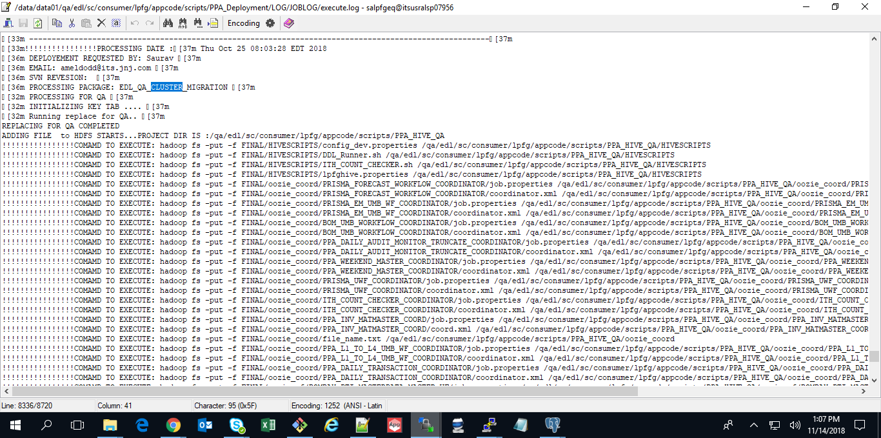

**Umbrella workflow execution**

PPD_FLAT_WF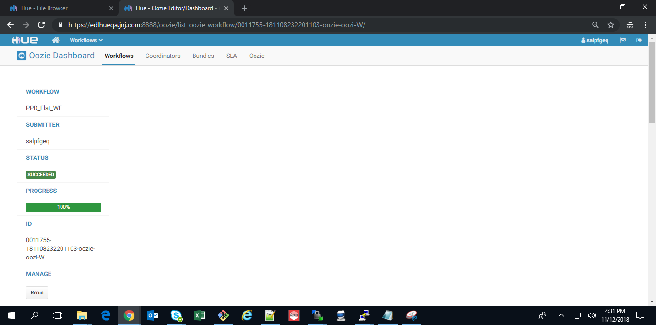

BOM_UMB_WF

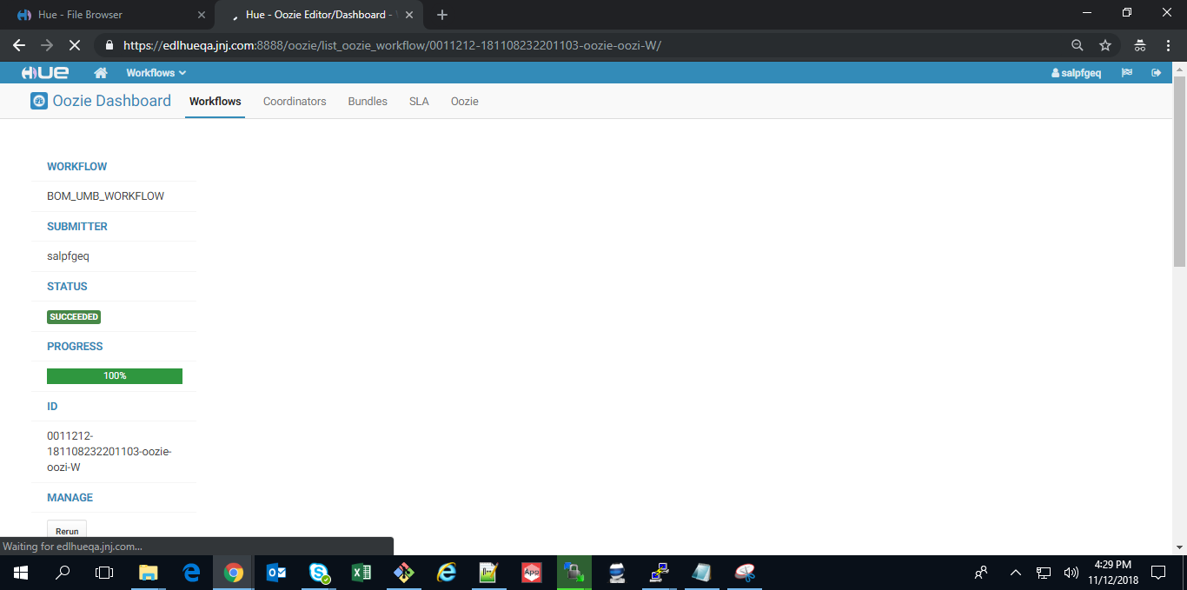

PRISMA_FORECAST_WF

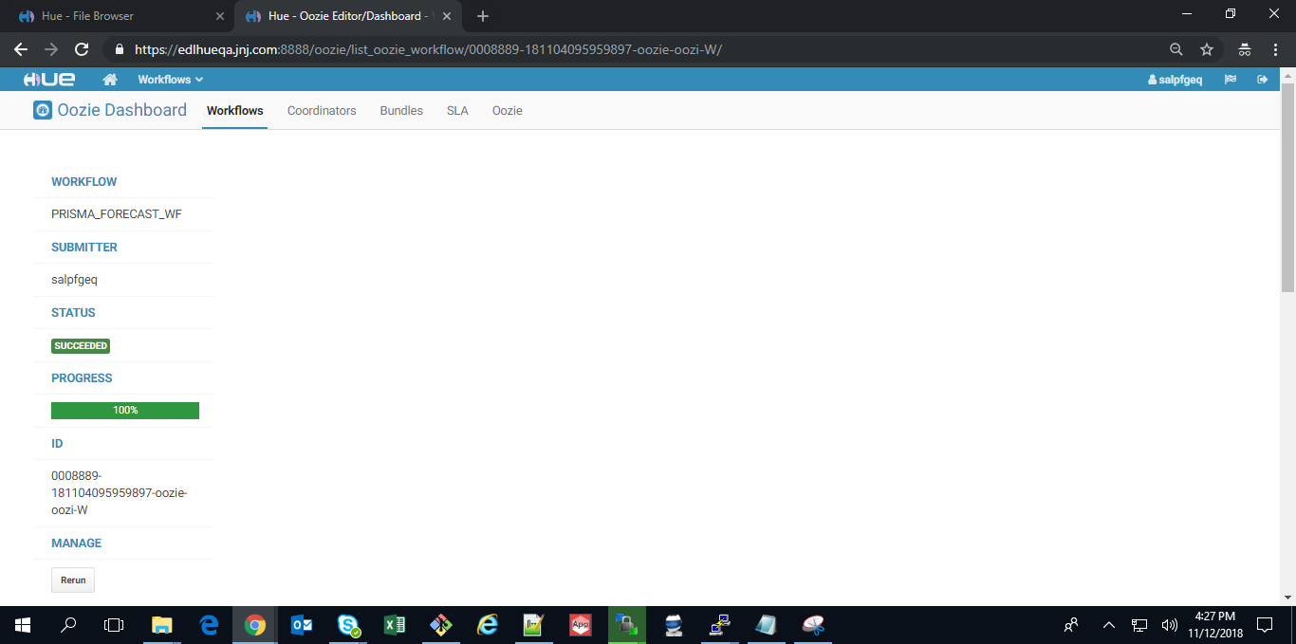

EM_UMB_WF

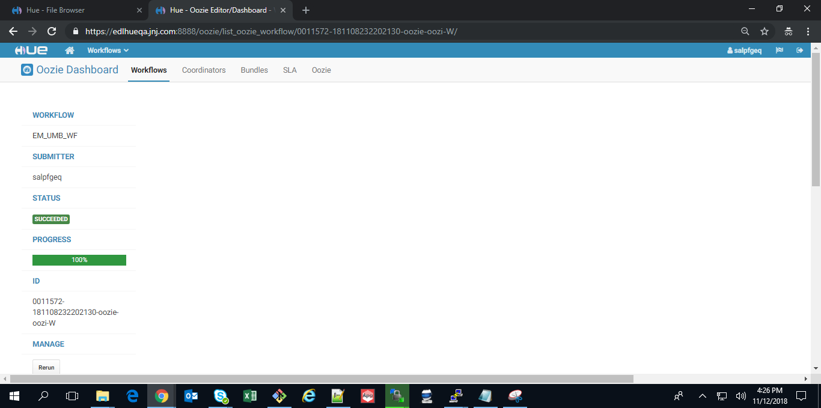

PPA_DAILY_AUDIT_MONITOR_TRUNCATE_WF

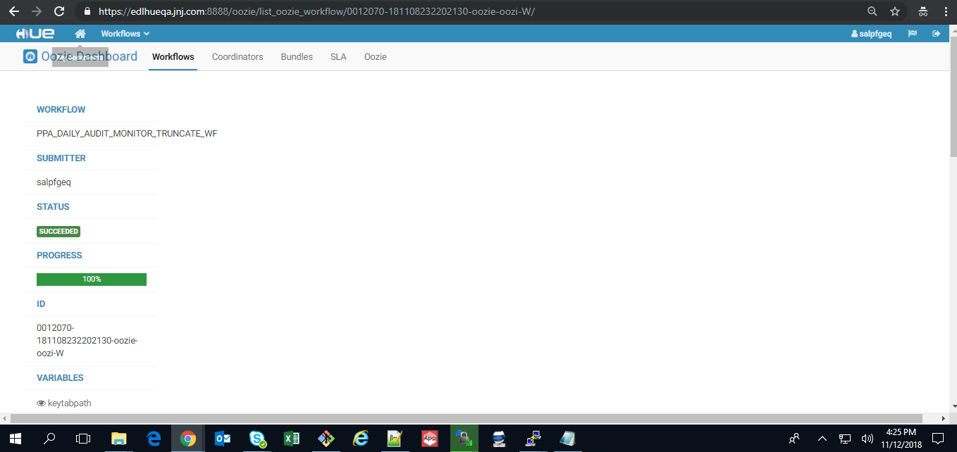

PPA_WEEKEND_MASTER_UMB_WF

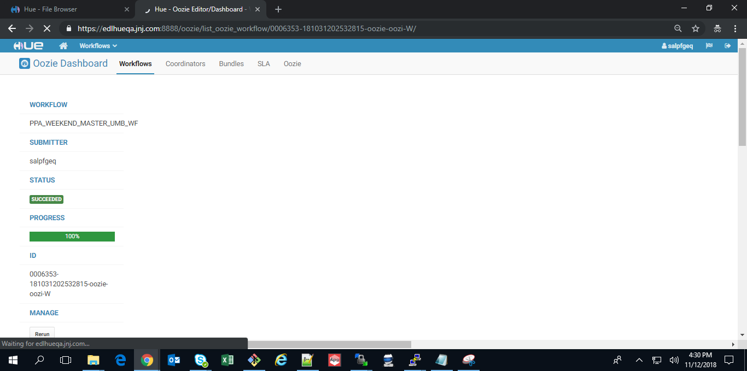

PPA_L1_TO_L4_UMB_WF

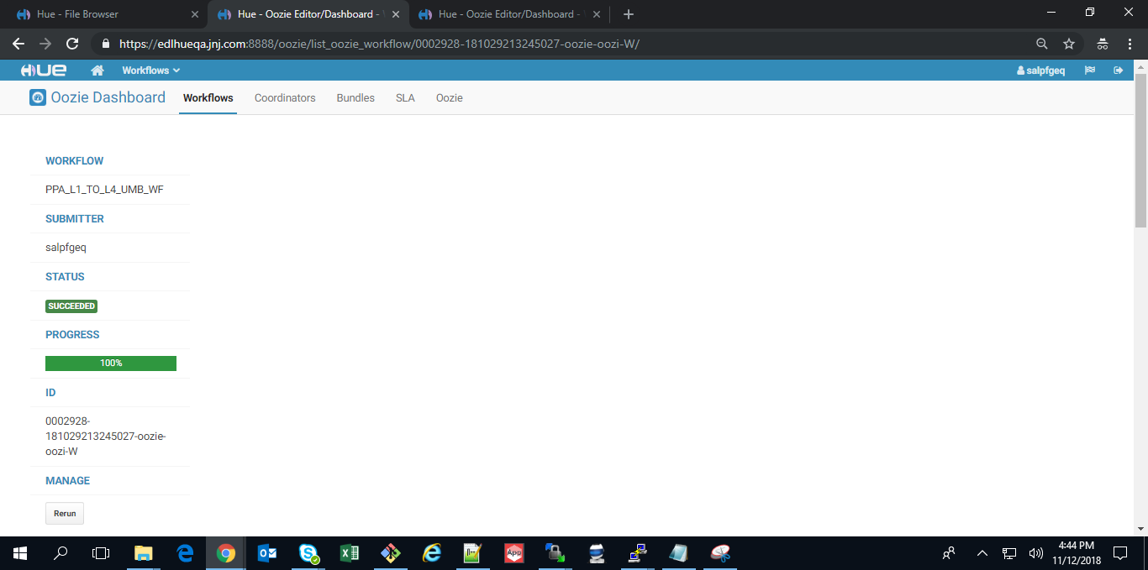

PPA_DAILY_TRANSACTION_UMB_WF

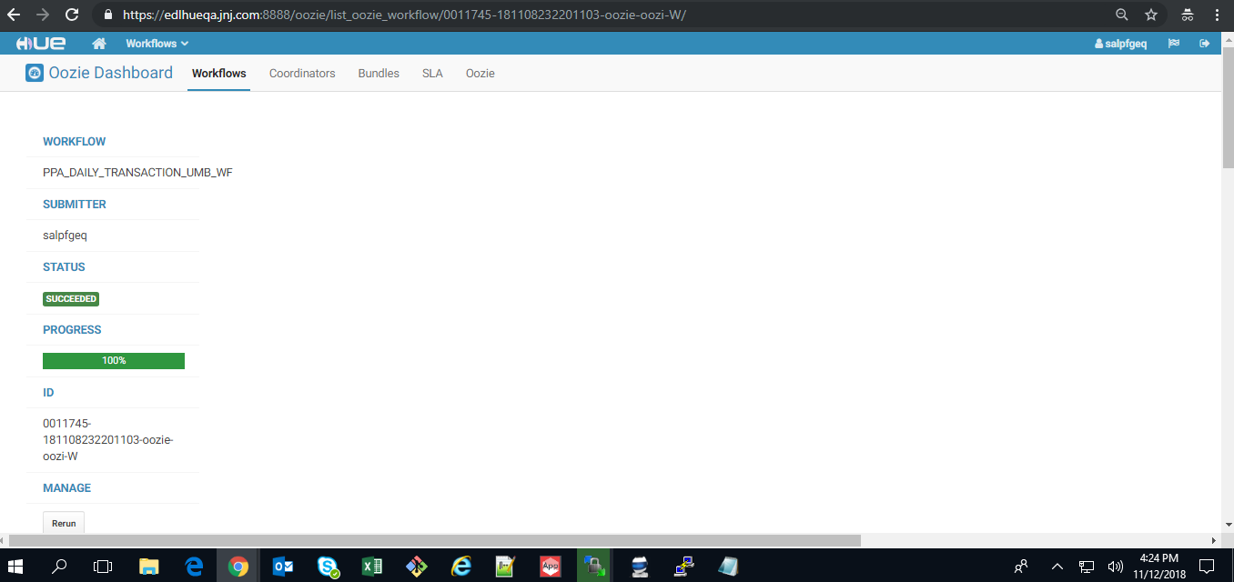

**Rollback Strategy**

• hadoop fs -mkdir /prod/edl/sc/consumer/lpfg/appcode/scripts/PPA_HIVE_PROD/PPA_BACKUP/PPA_BACKUP_16NOV18_EDL_QA_CLUSTER_MIGRATION

• hadoop fs -cp /prod/edl/sc/consumer/lpfg/appcode/scripts/PPA_HIVE_PROD/HIVESCRIPTS /prod/edl/sc/consumer/lpfg/appcode/scripts/PPA_HIVE_PROD/PPA_BACKUP/PPA_BACKUP_16NOV18_EDL_QA_CLUSTER_MIGRATION/

• hadoop fs -cp /prod/edl/sc/consumer/lpfg/appcode/scripts/PPA_HIVE_PROD/oozie_wf /prod/edl/sc/consumer/lpfg/appcode/scripts/PPA_HIVE_PROD/PPA_BACKUP/PPA_BACKUP_16NOV18_EDL_QA_CLUSTER_MIGRATION/

* hadoop fs -cp /prod/edl/sc/consumer/lpfg/appcode/scripts/PPA_HIVE_PROD/oozie_coord /prod/edl/sc/consumer/lpfg/appcode/scripts/PPA_HIVE_PROD/PPA_BACKUP/PPA_BACKUP_16NOV18_EDL_QA_CLUSTER_MIGRATION/

1. Package deployment steps

cd /data/data01/prod/edl/sc/consumer/lpfg/appcode/scripts/PPA_Deployment/PPA/

1. chmod -R 771 **EDL_QA_CLUSTER_MIGRATION**
2. chown -R salpfgep **EDL_QA_CLUSTER_MIGRATION**
3. cd **EDL_QA_CLUSTER_MIGRATION**
4. chmod 755 deploy.sh
5. sh deploy.sh

**Run the below command:**

* 1. Copy the files from QA to PROD

QA path: /qa/edl/sc/consumer/lpfg/appcode/scripts/jars/FlatFileValidation.jar

PROD path: /prod/edl/sc/consumer/lpfg/appcode/scripts/jars/FlatFileValidation.jar

* 1. Copy the files from QA to PROD

QA path: /qa/edl/sc/consumer/lpfg/appcode/scripts/BOMBAY/jars/XMLFileValidation.jar

PROD path: /prod/edl/sc/consumer/lpfg/appcode/scripts/BOMBAY/jars/XMLFileValidation.jar

**Coordinator Set Up:**

oozie job -oozie https://edloozieprod.jnj.com:11443/oozie -config /data/data01/prod/edl/sc/consumer/lpfg/appcode/scripts/PPA_Deployment/PPA/EDL_QA_CLUSTER_MIGRATION/FINAL/oozie_coord/PRISMA_EM_UMB_WF_COORDINATOR/job.properties -submit -Dfrequency_trans="00 23 * * 1-7" -Dstart_date=`date -u "+%Y-%m-%dT%H:00Z"` -Dend_date='2020-06-29T06:09Z'

oozie job -oozie https://edloozieprod.jnj.com:11443/oozie -config /data/data01/prod/edl/sc/consumer/lpfg/appcode/scripts/PPA_Deployment/PPA/EDL_QA_CLUSTER_MIGRATION/FINAL/oozie_coord/PRISMA_FORECAST_WORKFLOW_COORDINATOR/job.properties -submit -Dfrequency_trans="30 00 * * 4" -Dstart_date=`date -u "+%Y-%m-%dT%H:00Z"` -Dend_date='2020-06-29T06:09Z'

oozie job -oozie https://edloozieprod.jnj.com:11443/oozie -config /data/data01/prod/edl/sc/consumer/lpfg/appcode/scripts/PPA_Deployment/PPA/EDL_QA_CLUSTER_MIGRATION/FINAL/oozie_coord/PPA_WEEKEND_MASTER_COORDINATOR/job.properties -submit -Dfrequency_master="30 05 * * 1" -Dstart_date=`date -u "+%Y-%m-%dT%H:00Z"` -Dend_date='2020-06-29T06:09Z'

oozie job -oozie https://edloozieprod.jnj.com:11443/oozie -config /data/data01/prod/edl/sc/consumer/lpfg/appcode/scripts/PPA_Deployment/PPA/EDL_QA_CLUSTER_MIGRATION/FINAL/oozie_coord/PPA_DAILY_TRANSACTION_COORDINATOR/job.properties -submit -Dfrequency_trans="00 04 * * 2-6" -Dstart_date=`date -u "+%Y-%m-%dT%H:00Z"` -Dend_date='2020-06-29T06:09Z'

oozie job -oozie https://edloozieprod.jnj.com:11443/oozie -config /data/data01/prod/edl/sc/consumer/lpfg/appcode/scripts/PPA_Deployment/PPA/EDL_QA_CLUSTER_MIGRATION/FINAL/oozie_coord/BOM_UMB_WORKFLOW_COORDINATOR/job.properties -submit -Dfrequency_trans="30 12 * * 7" -Dstart_date=`date -u "+%Y-%m-%dT%H:00Z"` -Dend_date='2020-06-29T06:09Z'

oozie job -oozie https://edloozieprod.jnj.com:11443/oozie -config /data/data01/prod/edl/sc/consumer/lpfg/appcode/scripts/PPA_Deployment/PPA/EDL_QA_CLUSTER_MIGRATION/FINAL/oozie_coord/ITH_COUNT_CHECKER_COORDINATOR/job.properties -submit -Dfrequency_trans="00 07 * * 2-6" -Dstart_date=`date -u "+%Y-%m-%dT%H:00Z"` -Dend_date='2020-06-29T06:09Z'

oozie job -oozie https://edloozieprod.jnj.com:11443/oozie -config /data/data01/prod/edl/sc/consumer/lpfg/appcode/scripts/PPA_Deployment/PPA/EDL_QA_CLUSTER_MIGRATION/FINAL/oozie_coord/PPA_DAILY_AUDIT_MONITOR_TRUNCATE_COORDINATOR/job.properties -submit -Dfrequency_trans="00 14 * * 1-7" -Dstart_date=`date -u "+%Y-%m-%dT%H:00Z"` -Dend_date='2020-06-29T06:09Z'

## Workflow Execution:

Please execute the commands in sequence

**Goto:-**

cd /data/data01/prod/edl/sc/consumer/lpfg/appcode/scripts/PPA_Deployment/PPA/EDL_QA_CLUSTER_MIGRATION/FINAL/oozie_wf/PPA_L1_TO_L4_UMB_WF

**Run the command:**

oozie job -oozie https://edlimpalaprod.jnj.com: 21000/oozie -config job.properties -run

**Go to: -**

cd /data/data01/prod/edl/sc/consumer/lpfg/appcode/scripts/PPA_Deployment/PPA/EDL_QA_CLUSTER_MIGRATION/FINAL/oozie_wf/PPA_DAILY_TRANSACTION_UMB_WF

**Run the command:**

oozie job -oozie https://edlimpalaprod.jnj.com: 21000/oozie -config job.properties -run

**Go to: -**

cd /data/data01/prod/edl/sc/consumer/lpfg/appcode/scripts/PPA_Deployment/PPA/EDL_QA_CLUSTER_MIGRATION/FINAL/oozie_wf/PPA_DAILY_TRANSACTION_UMB_WF

**Run the command:**

oozie job -oozie https://edlimpalaprod.jnj.com: 21000/oozie -config job.properties -run

**Go to: -**

cd /data/data01/prod/edl/sc/consumer/lpfg/appcode/scripts/PPA_Deployment/PPA/EDL_QA_CLUSTER_MIGRATION/FINAL/oozie_wf/PPA_WEEKEND_MASTER_UMB_WF

**Run the command:**

oozie job -oozie https://edlimpalaprod.jnj.com: 21000/oozie -config job.properties -run

**Go to: -**

cd /data/data01/prod/edl/sc/consumer/lpfg/appcode/scripts/PPA_Deployment/PPA/EDL_QA_CLUSTER_MIGRATION/FINAL/oozie_wf/BOM_UMB_WF

**Run the command:**

oozie job -oozie https://edlimpalaprod.jnj.com: 21000/oozie -config job.properties -run

**Updated Design_and_Release_Review_Checklist can be found in below mentioned location**

<https://jnj.sharepoint.com/:x:/r/teams/CON-TEAM-SHARED_2/STFProjects2010onwards/2015%20Projects/_layouts/15/Doc.aspx?sourcedoc=%7B707908FA-6A9A-4F99-832E-64410F3A06F9%7D&file=Design_and_Release_Review_Checklist.xlsx&action=default&mobileredirect=true>”

* + 1. **Resolution Information [To be filled by ITS]**

|  |  |
| --- | --- |
| Implemented Date |  |
| Change Control No. |  |

* + 1. **Migration Task Screenshots [To be filled by ITS]**

|  |
| --- |
|  |

1. Frequently Asked Questions:
2. How to submit a Service request to the EDL team?

Please duly fill the above section and attach the migration form to a service request (SR) in IRIS. Please follow the below mentioned “how-to” document to raise a SR in IRIS.

<http://wise.jnj.com/SharedServicesNonERP/BI/ClouderaEDL/Shared%20Documents/How%20to%20documents/How%20to%20Submit%20a%20Service%20Request%20to%20EDL%20Team.pdf>

1. How to contact the EDL team?

Mail to [DL-NCSUS-ITS-DATS-EDL-SUPPORT@ITS.JNJ.com](mailto:DL-NCSUS-ITS-DATS-EDL-SUPPORT@ITS.JNJ.com)